Unit 5

Infographic Sharing & Process Writing
This unit marks the transition from the infographic to the next theme in the course, writing an argumentative essay. Before this class, you should submit your infographic following your teacher’s instructions. In the first part of class, you will share your infographics with your classmates and provide feedback to each other. Then, aspects of the process writing approach will be introduced. The online module will focus on reading skills, which will help you gather information for your essay. Outside of class, you can start generating ideas for your essay. By the end of this unit, you will have:
- presented your infographic;
- had the opportunity to compare approaches to the infographic task;
- learned about how process writing can help you develop as a writer.

Activity 1: Infographic Sharing
You will now present your infographic to classmates and listen to them present theirs. During the sharing section, ask yourself the following questions:
- How well do the graphic elements succeed in providing information in the best possible format (as opposed to serving simply as illustrations)?
- What are the effective elements in each infographic?
- What elements could have worked better?
- What's one thing your group did better than average?
- What's one thing another group did better that you can learn from?

Activity 2: Process Writing
A process approach to writing assumes that good writing involves several stages and activities. Importantly, these can be recursive; having completed one stage, you can return to it if necessary. Some of the stages in the writing process are:
- generating ideas
- discarding ideas
- reading widely on the topic
- explaining your thoughts to a classmate
- planning the structure of your text
- writing a draft
- getting feedback on your draft
- revising
- proofreading

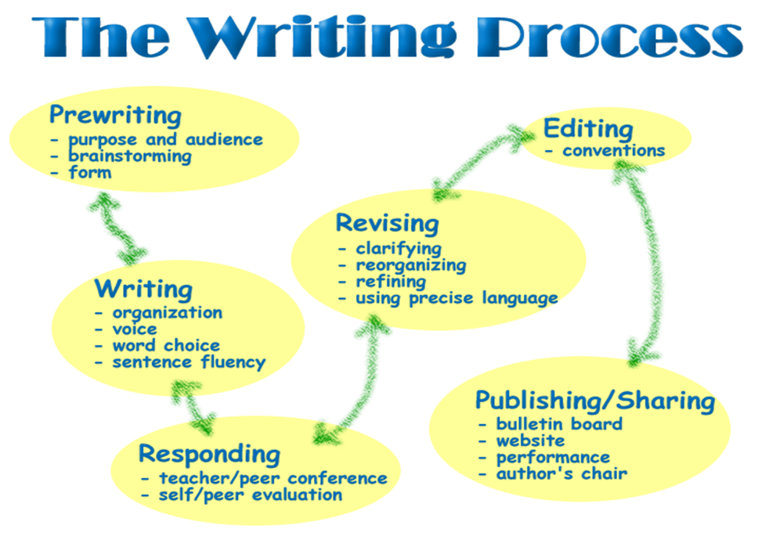

Discuss with your partner:
Q.1 Which stages did your group go through when you worked on the infographic?

Q.2 If you planned the infographic before you started preparing, how close was the final result to your original plans?
Q.3 If your plans changed, how and why?

Activity 3: Deciding on essay topics

Now use the following prompt to use an AI tool to help brainstorm some possible topics for your argumentative essay.

Using the content of the uploaded infographic about [infographic theme], suggest 5 argumentative essay topics. Ensure each topic is debatable, with clear opposing viewpoints and suitable for an academic discussion. There should also be sufficient scholarly sources to back up the conflicting perspectives.

